**IoT based smoke and gas detector**

**using an MQ2 Sensor, ESP8266 microcontroller, and Blynk IoT Cloud**. We have used the MQ2 Gas sensor module to detect Smoke, LPG, and carbon monoxide concentrations present in Air. MQ2 is a versatile sensor that can detect LPG, smoke, alcohol, propane, hydrogen, methane, carbon monoxide, etc. This makes the [MQ2 Gas Sensor](https://iotprojectsideas.com/smoke-gas-leakage-detector-using-arduino/) Module an excellent choice for building an [indoor air quality monitoring system](https://iotprojectsideas.com/iot-based-indoor-air-quality-monitoring-using-bme680-esp8266/), a [breathalyzer](https://iotprojectsideas.com/alcohol-detector-using-arduino-mq3-sensor/), or [an early fire detection system.](https://iotprojectsideas.com/gsm-based-fire-alert-system-using-arduino-and-flame-detector-sensor/)

This project has an OLED display to Display the **Smoke, LPG, and Carbon Monoxide** concentrations in PPM. The same data can be monitored on an Android app as well as Web Dashboard. We have two buttons that help to switch the monitoring screen between Smoke, LPG, and Carbon monoxide.

**Overview: IoT Smoke & Gas Detector**

First, let’s see how this project works. The sensor detects smoke, LPG, and Carbon Monoxide values and sends them to ESP8266 Microcontroller. Then it processes these values and displays these values on the OLED display as well as on the Blynk IoT Platform. It also checks if these values are above the safe level then it sends a notification to the Mobile phone as well as buzzer starts alarming with a flashing LED.

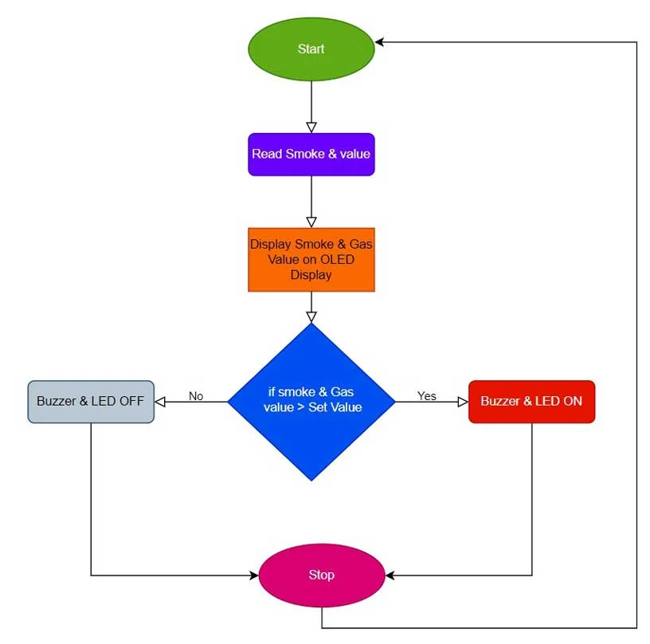

**Circuit Diagram: IoT Gas & Smoke Detector**

This is the circuit diagram of the **IoT Smoke & Gas Leakage Detector using ESP8266.**

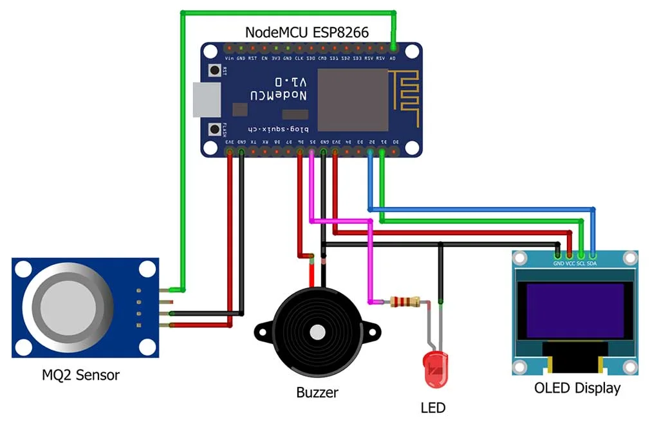

Here we have interfaced the MQ2 sensor **Analog Pin A0 pin** with the **A0 pin of ESP8266**. **VCC**and **GND**are connected to the **3.3 Volt and GND** pins of **ESP8266**respectively. After that, I connected the **I2C OLED** **VCC**pin to the **3.3V**pin of NodeMCU and its ground pin to the ground. Its **SCL and SDA** pins to the **D1**and **D2**pins of NodeMCU. After that, I connected an **LED**anode pin to the **D5**pin and its cathode pin to the ground. Lastly, I connected the buzzer’s positive pin to the **D6**pin of the NodeMCU and its negative pin to the Ground pin.

**Setting up Blynk IoT Dashboard**

In order to monitor the **Smoke, LPG, and CO** Data on Blynk IoT Server, you first need to set up the Blynk IoT Cloud dashboard. To set up the [Blynk](https://iotprojectsideas.com/iot-smoke-gas-detector-using-esp8266-blynk/)  Server, visit <https://blynk.cloud/>. Create an account or simply sign in if you created the account earlier.

**Creating Blynk New template**

A template is a project in which we can create a web and mobile dashboard for specific hardware. In our case, it’s a Smoke & Gas Detection System. For creating a project, first, you have to click on the New *Template*.

* Enter a template name. I am giving it a *“Smoke Detector”*.
* Select the*hardware board (ESP8266)*.
* The connection type will be *wifi*.
* You can add a description of your project if required.
* Click on Done.
* Now the template is created.

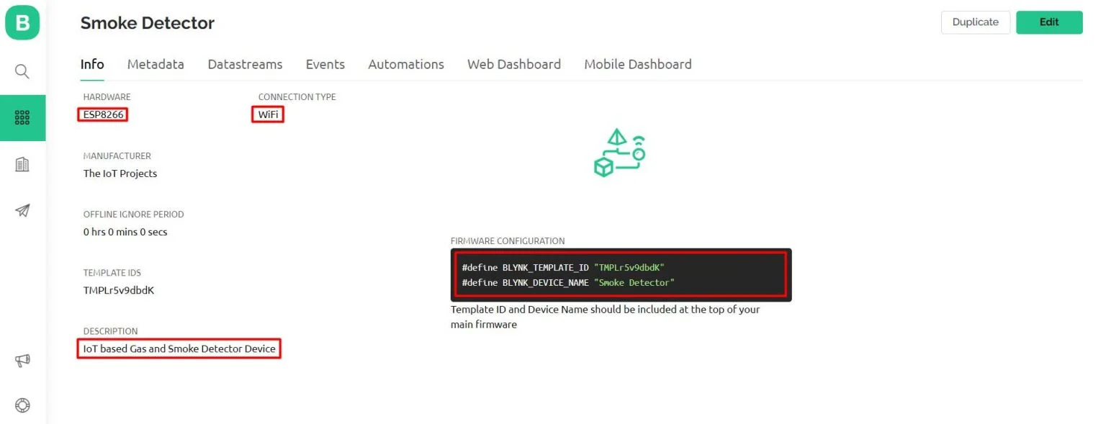

**Creating New Blynk Datastream**

In our project, we are monitoring five parameters. So you can give names to those parameters. In my case, **Smoke, LPG, CO, Button 1, and Button 2** are five DataStream.

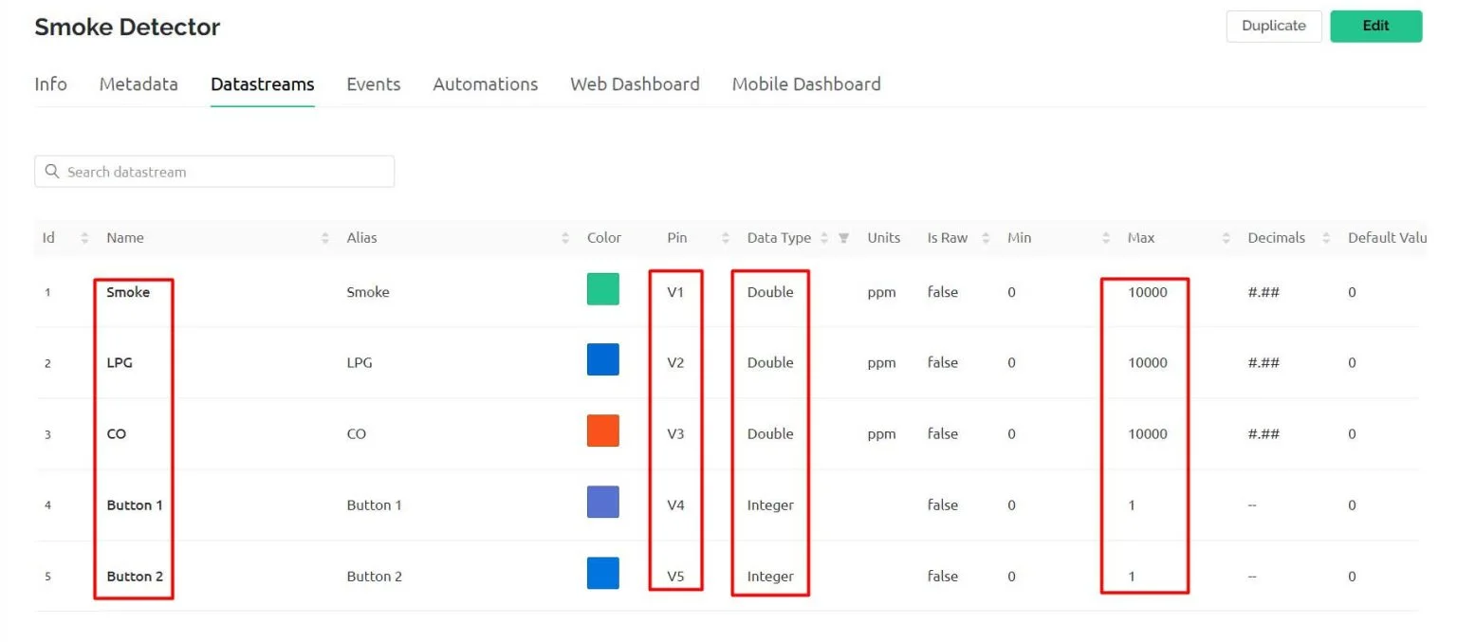

I have selected**V1 to V5** respectively for our DataStreams for the Live Monitoring. The Variable data type is Double for all the variables except Button 1 and Button 2 which is an Integer type. The maximum value for smoke, LPG, and CO is 10000 and the default value is set to zero for all data streams.

**Creating Events on Blynk for Notification Alerts**

Events are used for notification alert systems. So, here I am creating events to monitor Smoke. If the smoke value reaches above the threshold value an event is triggered and a notification is sent to your mobile phone.

**So to create an event:**

* Click on the add event.
* Enter the event Name. For me, it’s “*smoke*“
* Choose your event color. I am selecting *Red*.
* Select the type of event. I am choosing *Warning*.
* Enter the description of your event.
* then choose your limit to once every*1 minute*.
* Now go to the notification tab then *enable notification.*
* *Set Email and Push Notifications* to the *device owner.*
* *Also, turn on Deliver push notifications as alerts*
* Click on save.

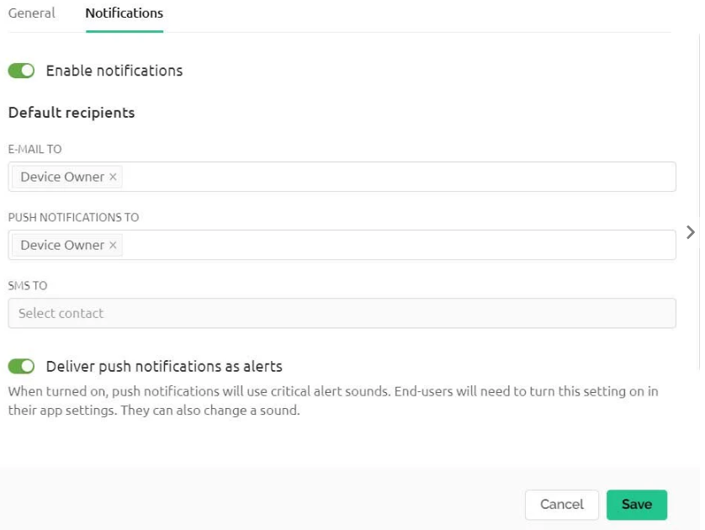

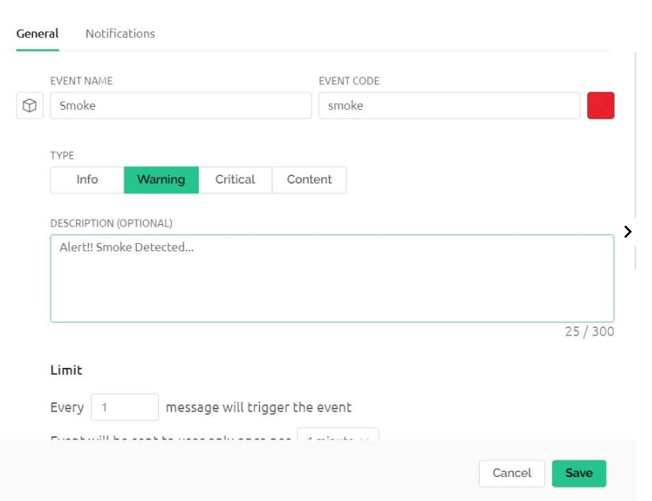

**Design the Blynk 2.0 Web Dashboard**

After that move on to the web dashboard. In this section, you will be able to see some widgets for making your cool-looking web dashboard. But all the widgets are not free. You will get it all if you purchase their upgrade plan.

For showing the value of *Smoke* I have selected *Gauge*. Label widget for LPG and CO value. Similarly, switch widgets for buttons. But, you can choose any widget according to your project. Now change the settings of the label. In settings, you have to give a name to the widget and you have to choose the *data stream* with which the widget will be connected. After setting up the widgets click on the *save* button to save the entire project. That’s all for setting up the [Blynk IoT](https://iotprojectsideas.com/iot-smoke-gas-detector-using-esp8266-blynk/) dashboard. We will set up the [Blynk](https://iotprojectsideas.com/iot-smoke-gas-detector-using-esp8266-blynk/) Mobile dashboard after uploading the program code.

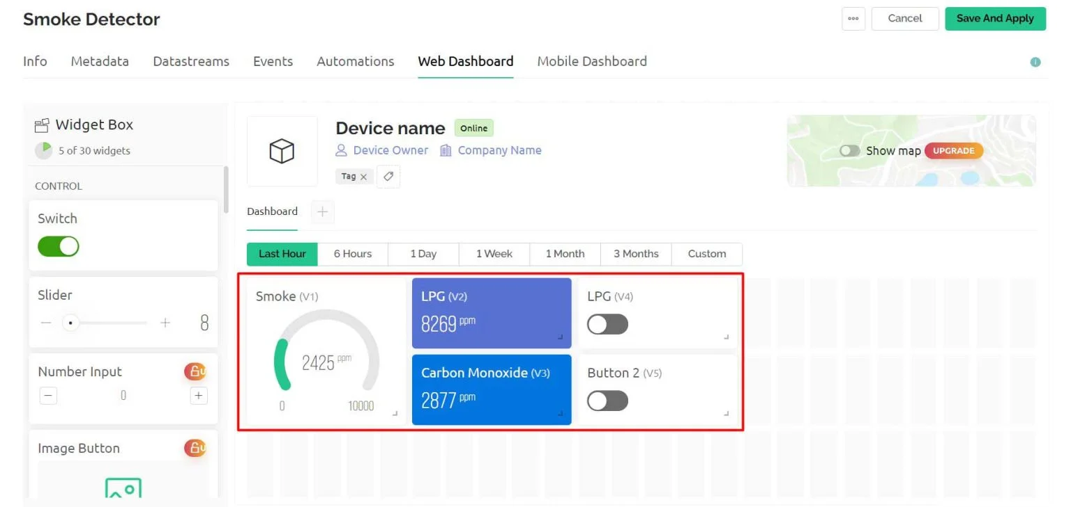

**Source Code/Program**

Here is the source code for the IoT Smoke & Gas Detector System using ESP8266. But, You need to install these libraries in your Arduino IDE before uploading the program code.

* [***MQ2 Library***](https://github.com/labay11/MQ-2-sensor-library)
* [***Blynk Library***](https://github.com/blynkkk/blynk-library)
* [***Adafruit_SSD1306 Library***](https://github.com/adafruit/Adafruit_SSD1306)
* [***Adafruit GFX Library***](https://github.com/adafruit/Adafruit-GFX-Library)

Now open your Arduino IDE. Go to ***File >> Examples >> Blynk >> Blynk.Edgent >> ESP8266_Edgent*.** Just copy the code provided below and paste it into your Arduino IDE ESP8266_Edgent page. Do not make any changes to other files. You need to replace your Blynk Template ID and Blynk Device Name which is available in the blynk template. Simply after making the necessary changes upload the code to NodeMCU ESP8266 12E Board.

Code

// Fill-in information from your Blynk Template here

#define BLYNK_TEMPLATE_ID "TMPLr5v9dbdK"

#define BLYNK_DEVICE_NAME "Smoke Detector"

#define BLYNK_FIRMWARE_VERSION "0.1.0"

#define BLYNK_PRINT Serial

//#define BLYNK_DEBUG

#define APP_DEBUG

// Uncomment your board, or configure a custom board in Settings.h

//#define USE_SPARKFUN_BLYNK_BOARD

#define USE_NODE_MCU_BOARD

//#define USE_WITTY_CLOUD_BOARD

//#define USE_WEMOS_D1_MINI

#include "BlynkEdgent.h"

#include <MQ2.h>

#include <SPI.h>

#include <Wire.h>

#include <Adafruit_GFX.h>

#include <Adafruit_SSD1306.h>

#define SCREEN_WIDTH 128 // OLED display width, in pixels

#define SCREEN_HEIGHT 64 // OLED display height, in pixels

#define OLED_RESET -1 // Reset pin # (or -1 if sharing Arduino reset pin)

#define SCREEN_ADDRESS 0x3C ///< See datasheet for Address; 0x3D for 128x64, 0x3C for 128x32

Adafruit_SSD1306 display(SCREEN_WIDTH, SCREEN_HEIGHT, &Wire, OLED_RESET);

#define BUZZ 12 //D6

#define LED 14 //D5

//change this with the pin that you use

int pin = A0;

float lpg, co, smoke;

MQ2 mq2(pin);

int button1 = 0;

int button2 = 0;

SimpleTimer timer;

void setup()

{

Serial.begin(115200);

delay(100);

BlynkEdgent.begin();

pinMode(BUZZ, OUTPUT);

pinMode(LED, OUTPUT);

digitalWrite(BUZZ, LOW);

digitalWrite(LED, LOW);

// calibrate the device

mq2.begin();

// SSD1306_SWITCHCAPVCC = generate display voltage from 3.3V internally

if (!display.begin(SSD1306_SWITCHCAPVCC, SCREEN_ADDRESS)) {

Serial.println(F("SSD1306 allocation failed"));

for (;;); // Don't proceed, loop forever

}

delay(2000);

display.clearDisplay();

display.setTextSize(2);

display.setTextColor(SSD1306_WHITE); // Draw white text

display.setCursor(0, 0);

display.println(" IoT Smoke ");

display.setCursor(0, 20);

display.println(" Detector ");

display.display();

delay(1000);

timer.setInterval(1000L, sendSensorData);

}

void loop() {

timer.run(); // Initiates SimpleTimer

BlynkEdgent.run();

}

void sendSensorData()

{

float* values = mq2.read(true); //set it false if you don't want to print the values to the Serial

co = mq2.readCO();

smoke = mq2.readSmoke();

lpg = mq2.readLPG();

if (button1 == 1)

{

// display LPG

display.clearDisplay();

display.setTextSize(2);

display.setCursor(0, 0);

display.print(" LPG ");

display.setCursor(10, 30);

display.print(lpg);

display.setTextSize(1);

display.print(" PPM");

delay(5000);

display.display();

}

else if (button2 == 1)

{

// display CO

display.clearDisplay();

display.setTextSize(2);

display.setCursor(0, 0);

display.print(" CO ");

display.setCursor(10, 30);

display.print(co);

display.setTextSize(1);

display.print(" PPM");

delay(5000);

display.display();

}

else {

// display Smoke

display.clearDisplay();

display.setTextSize(2);

display.setCursor(0, 0);

display.print(" SMOKE ");

display.setCursor(10, 30);

display.print(smoke);

display.setTextSize(1);

display.print(" PPM");

delay(5000);

display.display();

}

Blynk.virtualWrite(V1, smoke);

Blynk.virtualWrite(V2, lpg);

Blynk.virtualWrite(V3, co);

if (smoke > 50 ) {

Blynk.logEvent("smoke", "Smoke Detected!");

digitalWrite(BUZZ, HIGH);

digitalWrite(LED, HIGH);

}

else {

digitalWrite(BUZZ, LOW);

digitalWrite(LED, LOW);

}

}

// in Blynk app writes values to the Virtual Pin 4

BLYNK_WRITE(V4)

{

button1 = param.asInt(); // assigning incoming value from pin V4 to a variable

}

// in Blynk app writes values to the Virtual Pin 5

BLYNK_WRITE(V5)

{

button2 = param.asInt(); // assigning incoming value from pin V5 to a variable

}

**Conclusion**

Alright, that’s all for the [**MQ2**](https://iotprojectsideas.com/iot-smoke-gas-detector-using-esp8266-blynk/)**Sensor Based IoT Smoke Detector using ESP8266 & Blynk IoT**. This project is very helpful for monitoring our internal (home) environment wirelessly. The complete project details including device information purchase link source code and written guide are provided for you. I hope you enjoyed reading this article. In case you have any other questions you can comment in the comment section below.